# **Code signature**

Table of Contents

Code signature 1

1. About code signature 2

1.1 public key and private key 2

1.2 Common case 2

1.3 Digest and signature 4

1.4 certificate authority center and Digital certification 8

1.5 Communicate with certificate authority center and Digital certification 9

2. Security 10

2.1 ssl 10

3. Mac OSx 11

4. Windows 12

5. Ios 13

6. Android 14

7. Linux 15

# About code signature

## 1.1 public key and private key

**Public and private key:**

<http://www.ruanyifeng.com/blog/2013/06/rsa_algorithm_part_one.html>

<http://www.ruanyifeng.com/blog/2013/07/rsa_algorithm_part_two.html>

**Case example:**

Chinese version:

<http://www.blogjava.net/yxhxj2006/archive/2012/10/15/389547.html>

English version:

<http://www.youdzone.com/signature.html>

## 1.2 Common case

* **Bob: AliPay 777-xxxx-666**
* **Susan: AliPay 123-xxxx-666**
* **Doug: AliPay 456-xxxx-666**
* **Pat**







**Doug also has Bob’s public key, he wants to pretend to be Susan**



## 1.3 Digest and signature

basic concept about digest and signature



**Common case for using digest and signature**



**Vulnerability：**

**case for using digest and signature**





## 1.4 CA--certificate authority center and Digital certification

**Susan not sure the public key is from Bob or from Doug.**

**So Susan does not trust the public key.**

**And she want to get this from CA center, which certificate that the Bob’s public key**



## Communicate based on CA

**Now Susan can verify that the Bob’s public key did come from Bob**

**As it has been certificated by CA**



## Example for certification on Mac

**Go to keychain access**

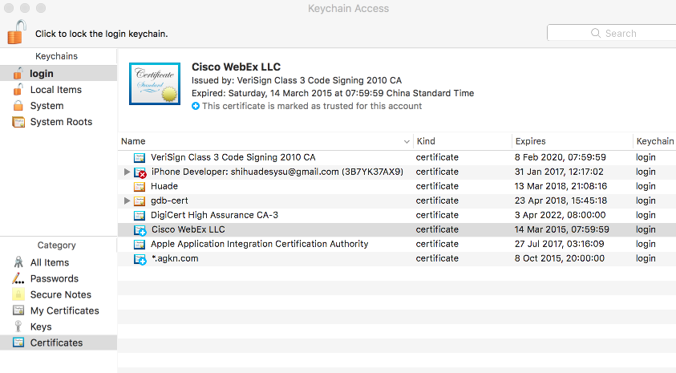

**Public key info for Cisco WebEx LLC**

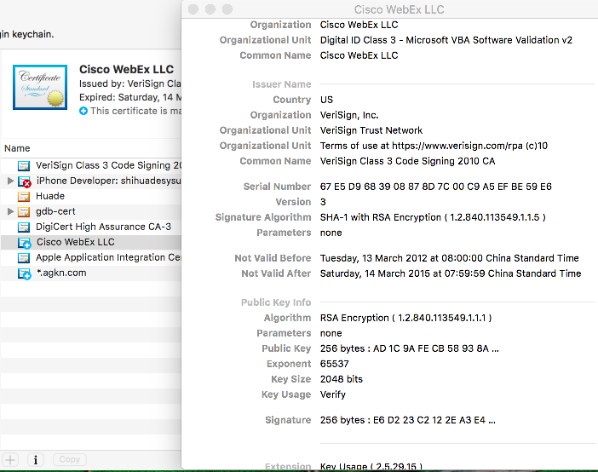

**Symantec’s CA for Cisco WebExLLC**

<https://www.symantec.com/about/legal/repository.jsp#rpa-ts>

## Example for certification on website

**Google website:**

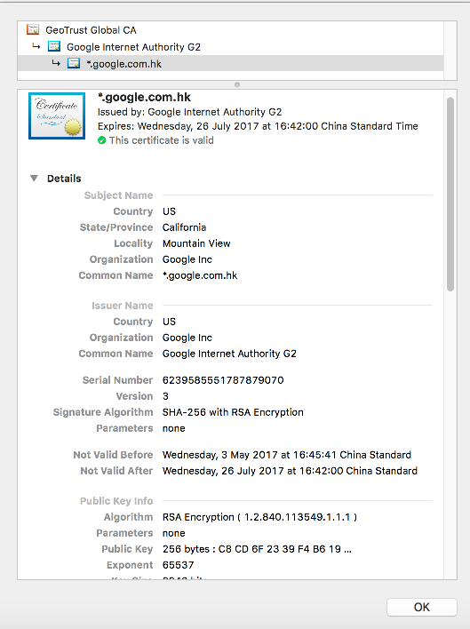

**Baidu website:**

**Baidu’s CA:** <https://www.globalsign.com/en/repository/>

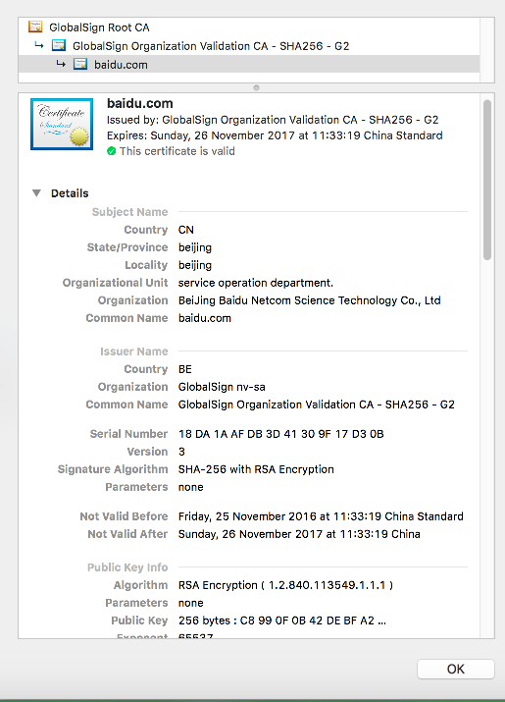

**ICBC net bank**

<https://mybank.icbc.com.cn/icbc/newperbank/perbank3/frame/frame_index.jsp>

**CA by Symantec:**

<https://www.symantec.com/about/legal/repository.jsp#stn-cps>

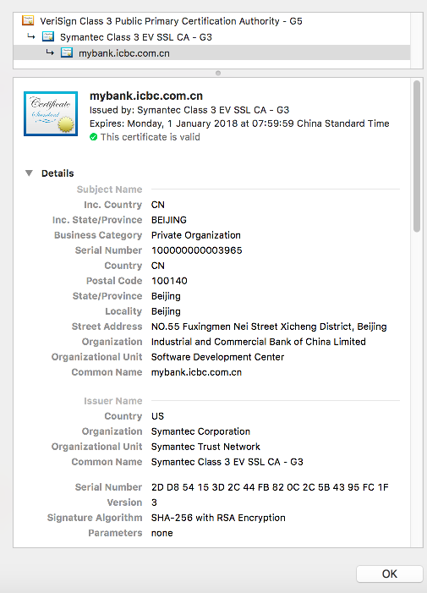

## Example for certification for ios developer

1

# Security

## ssl

<https://gist.github.com/colinstein/de1755d2d7fbe27a0f1e>

CA

<https://www.symantec.com/content/en/us/about/media/repository/root-certificates.pdf>

# Mac OSx

http://osxdaily.com/2016/03/14/verify-code-sign-apps-mac-os-x/

<https://www.digicert.com/code-signing/mac-os-codesign-tool.htm>

<http://osxdaily.com/2016/03/14/verify-code-sign-apps-mac-os-x/>

<https://developer.apple.com/library/content/documentation/Security/Conceptual/CodeSigningGuide/Procedures/Procedures.html>

<https://developer.apple.com/library/content/technotes/tn2206/_index.html>

<https://support.apple.com/en-us/HT202369>

<http://blog.leanote.com/post/yinhaide/MAC%E7%8E%AF%E5%A2%83%E4%B8%8B%E7%94%9F%E6%88%90Apple%E8%AF%81%E4%B9%A6%E6%95%99%E7%A8%8B>

# Windows

<https://msdn.microsoft.com/en-us/library/ms537362(v=vs.85).aspx>

<https://msdn.microsoft.com/en-us/library/ms537361(v=vs.85).aspx>

# Ios

<http://foggry.com/blog/2014/10/16/ios-code-signing-xue-xi-bi-ji/>

# Android

# Linux